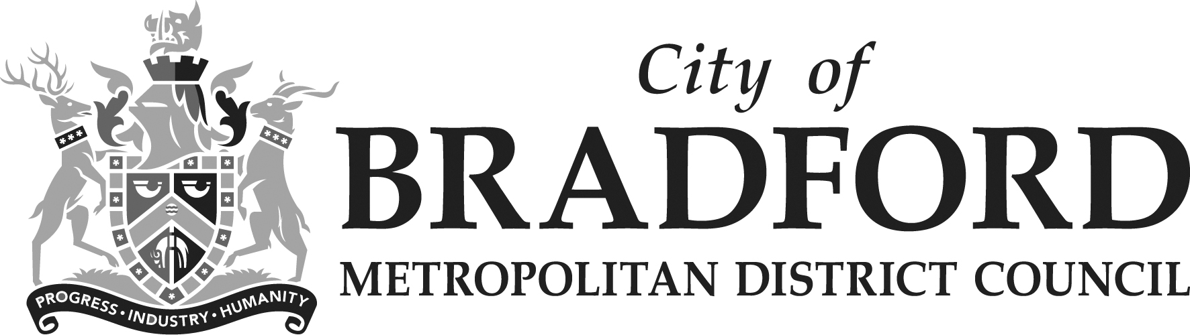
Instruction to your bank or building society to pay by Direct Debit |  |  |  |  |  |  |  |  |  |  |  |  |  |  |  |  |  |  |  |  |  |  |  |  |  |  |  | 
Please fill in the whole form in ball point pen and send it to: |  |  |  |  |  |  |  |  |  |  |  |  |  |  |  |  |  |  |  |  |  |  |  |  |  |  |  | Service user number
City of Bradford Metropolitan District Council  Music & Arts Service  21 Market Square  Shipley  West Yorkshire  BD18 3QD |  |  |  |  |  |  |  |  |  |  |  |  |  |  |  |  |  |  |  |  |  |  |  |  |  |  |  | 6 | 8 | 0 | 7 | 5 | 7
FOR CITY OF BRADFORD METROPOLITAN DISTRICT COUNCIL
This is not part of the instruction to your bank or building society.
For identification purposes please complete this box.

Name(s) of account holder(s)
Instrumental Lessons with Music & Arts Service
Payer Name:……………………………………
Address……………………………………….…
……………………………………………………

Tel.No……………………………………………
Mobile……………………………………………

Bank/building society account number
Branch sort code |  |  |  |  |  |  |  |  |  |  |  |  |  |  |  |  |  |  |  |  |  |  |  |  |  |  |  | Instruction to your bank or building society  Please pay City of Bradford Metropolitan District Council Direct Debits from the account detailed in this Instruction subject to the safeguards assured by the Direct Debit Guarantee. I understand that this Instruction may remain with City of Bradford Metropolitan District Council and, if so, details will be passed electronically to my bank/building society.
Name and full postal address of your bank or building society
To: The Manager |  |  |  |  |  |  |  |  |  |  |  | Bank/building society
Address |  |  |  |  |  |  |  |  |  |  |  |  |  |  |  |  |  |  |  |  |  |  |  |  |  |  |  | Signature(s)
 |  |  |  |  |  |  |  |  |  |  |  |  |  | Postcode |  |  |  |  |  |  |  |  |  |  |  |  |  | Date
Reference
Banks and building societies may not accept Direct Debit Instructions for some types of account
DDI1

This guarantee should be detached and retained by the payer.
The
Direct Debit
Guarantee
- This Guarantee is offered by all banks and building societies that accept instructions to pay Direct Debits
- If there are any changes to the amount, date or frequency of your Direct Debit City of Bradford Metropolitan District Council will notify you 10 working days in advance of your account being debited or as otherwise agreed. If you request City of Bradford Metropolitan District Council to collect a payment, confirmation of the amount and date will be given to you at the time of the request.
- If an error is made in the payment of your Direct Debit, by City of Bradford Metropolitan District Council or your bank or building society you are entitled to a full and immediate refund of the amount paid from your bank or building society
– If you receive a refund you are not entitled to, you must pay it back when City of Bradford Metropolitan District Council asks you to
- You can cancel a Direct Debit at any time by simply contacting your bank or building society. Written confirmation may be required. Please also notify us.

